**THIRD YEAR TE (ELECTRONICS)**

**MINI PROJECT PROPOSAL (2019-20)**

**MICROCONTROLLER AND APPLICATIONS**

|  |  |  |  |
| --- | --- | --- | --- |
| **Sr.No** | **Name** | **Class** | **Roll No.** |
| 1. | Kunal Bhor | D11B | 04 |
| 2. | Nidhi Jain | D11B | 18 |
| 3. | Tanmay Kothale | D11B | 21 |

**Name of faculty**:- Mrs. Anushree Prabhu

**Project Title**:- Smart Classroom using STM32 microcontroller.

**Introduction**:- Nowadays, everything is automated. Artificial intelligence is taking over all the areas of life rapidly. Hence, in addition to this, “Smart Classroom” is something which will have a count of students present in the room, and will control the flow of electricity throughout the room depending on the number of people sitting inside.

**Hardware required** : STM32 microcontroller, wires, LDR, Temperature Sensors, IR sensors, LED’s, DC motor, motor driver.   
**Software required**: Arduino IDE.

**Plan of implementation**:- Firstly, we will interface different sensors like temperature sensor and IR sensors with the microcontroller. After making a basic prototype ready for all the sensors, we will start implementing the interfacing of sensors together. Once all the sensors are working finely together, we will implement a code which will control the classroom.

IR sensors are used to keep a count of people entering and leaving.

Temperature sensors are used to check the room temperature and use the ventilating devices according to the surrounding temperature.

LDR is used to see the availability of the natural light in the surroundings and accordingly, the light in the classroom will be turned on and off, depending on the number of people in the room.

**Block Diagram:**

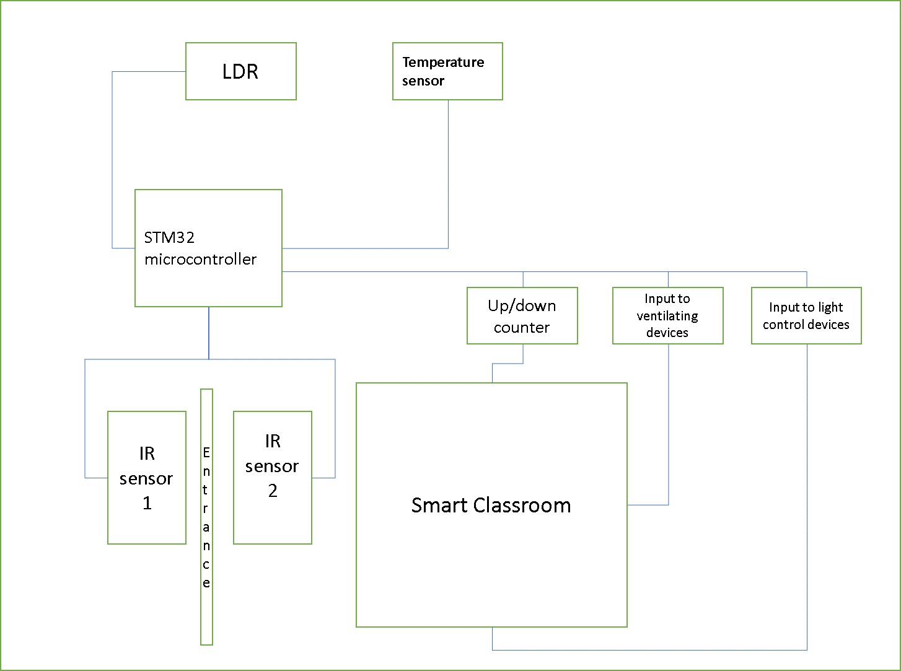

**Application**:- As the name suggests, this can be widely used in classrooms, seminar halls, auditoriums.

**Budget:**- As we are implementing the project for lower voltage values and smaller scale, approximately expense of Rs. 600/- is expected.

**Signature of the Faculty**